DAILY ASSESSMENT REPORT

|  |  |  |  |
| --- | --- | --- | --- |
| Date: | 12 June 2020 | Name: | Persis P |
| Course: | AC DC Analysis of Diode - Electronics Engineering | USN: | 4AL17EC069 |
| Topic: | * Basic of Electronics * PN Junction * What Is Diode & How It Works (DC AC Analysis of Diode) * Voltage Current   Characteristics of Diode (DC  AC Analysis of Diode)   * Electronics Engineering * Diode Models (DC AC Analysis of Diode) | Semester & Section: | 6th sem & B sec |
| GitHub  Repository: |  |  |  |

|  |
| --- |
| FORENOON SESSION DETAILS |
| Image of session |

Report

–

Report can be typed or hand written for up to two pages.

Basic of Electronics

:

•

PN Junction

•

A p

-

n junction is an interface or a boundary between two semiconductor material types,

namely the p

-

type and the n

-

type, inside a semiconductor. The p

-

side or the positive side of

the semico

nductor has an excess of holes and the n

-

side or the negative side has an excess

of electrons.

•

A diode is a two

-

terminal electronic component that conducts current primarily in one

direction (asymmetric conductance)

•

Diodes can be used as rectifiers, signal limiters, voltage regulators, switches, signal

modulators, signal mixers, signal demodulators

, and oscillators. The fundamental property

of a diode is its tendency to conduct electric current in only one direction.

•

Different Types of Diodes. There are several types of diodes are available for use in

electronics design, namely; a Backward diode, BARITT diode, Gunn Diode, Laser diode,

Light emitting diodes, Photodiode, PIN diode, PN Junction, Schottky diodes, Step reco

very

diode, Tunnel diode, Varactor diode and a Zener diode.

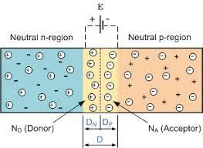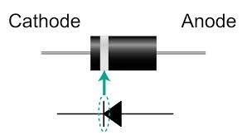

Voltage Current Characteristics of Diode

:

•

VI Characteristics of PN Junction Diode in forwarding Bias

•

The slope of the PN junction diode in

forwarding bias shows the resistance is very low.

When a forward bias is applied to the diode then it causes a low impedance path and

permits to conduct a large amount of current which is known as infinite current.

•

VI Characteris

tics of PN Junction Diode in Reverse Bias

•

The current in this biasing is low till breakdown is reached and hence the diode looks like

an open circuit. When the input voltage of the reverse bias has reached the breakdown

voltage, reverse current increases e

normously.

•

Diode models are used to approximate the diode characteristic curve as a series of linear

segments. The real diode is modeled as 3 components in series: an ideal diode, a voltage

sourc

e and a resistor. This shows a real diode I

-

V curve being approximated by a two

-

segment piece

-

wise linear model.

•

An ideal diode is a diode that acts like a perfect conductor when voltage is applied forward

biased and like a per

fect insulator when voltage is applied reverse biased. So when positive

voltage is applied across the anode to the cathode, the diode conducts forward current

instantly.

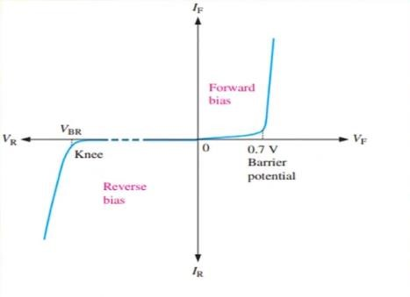

|  |  |  |  |
| --- | --- | --- | --- |
| Date: | 12 June 2020 | Name: | Persis P |
| Course: | MySQL | USN: | 4AL17EC069 |
| Topic: | PHP sequrity,creating a custom error handler,types of error,PHP functions | Semester & Section: | 6th sem & B sec |

|  |  |
| --- | --- |
| AFTERNOON SESSION DETAILS |  |
| Image of session:    C:\Users\user\AppData\Local\Microsoft\Windows\INetCache\Content.Word\Screenshot (318).png        PHP sequrity:  With PHP security, there are two sides to error reporting. One is beneficial to increasing security, the other is detrimental. Regardless of the method of error handling, the ability to probe a system for errors leads to providing an attacker with more information. PHP Error Handling: When creating scripts and web applications, error handling is an important part. If your code lacks error checking code, your program may look very unprofessional and you may be open to security risks.  Some of the most common error checking methods in PHP.  We will show different error handling methods:   * Simple "die()" statements * Custom errors and error triggers * Error reporting   Example:  <?php if(file_exists("mytestfile.txt")) {   $file = fopen("mytestfile.txt", "r"); } else {   die("Error: The file does not exist."); } ?> Creating a Custom Error Handler: Creating a custom error handler is quite simple. We simply create a special function that can be called when an error occurs in PHP.This function must be able to handle a minimum of two parameters (error level and error message) but can accept up to five parameters (optionally: file, line-number, and the error context):  Syntax:  error_function(error_level,error_message, error_file,error_line,error_context)  Types of error  Basically there are four types of errors in PHP, which are as follows:   * Parse Error (Syntax Error) * Fatal Error * Warning Error * Notice Error   1. Parse Errors (syntax errors)  The parse error occurs if there is a syntax mistake in the script; the output is Parse errors. A parse error stops the execution of the script. There are many reasons for the occurrence of parse errors in PHP. The common reasons for parse errors are as follows:  Common reason of syntax errors are:   * Unclosed quotes * Missing or Extra parentheses * Unclosed braces * Missing semicolon   Example  <?php echo "Cat"; echo "Dog" echo "Lion"; ?>  2. Fatal Errors  Fatal errors are caused when PHP understands what you've written, however what you're asking it to do can't be done. Fatal errors stop the execution of the script. If you are trying to access the undefined functions, then the output is a fatal error.  Example  <?php function fun1() { echo "Vineet Saini"; } fun2(); echo "Fatal Error !!"; ?>    3.Warning Errors  Warning errors will not stop execution of the script. The main reason for warning errors are to include a missing file or using the incorrect number of parameters in a function.  Example  <?php echo "Warning Error!!"; include ("Welcome.php"); ?>  4. Notice Errors  Notice that an error is the same as a warning error i.e. in the notice error execution of the script does not stop. Notice that the error occurs when you try to access the undefined variable, then produce a notice error.  Example  <?php $a="Vineet kumar saini"; echo "Notice Error !!"; echo $b; |  |